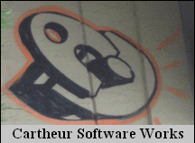

Copyright ©2010 Cartheur Software, The Netherlands

Easy Translate

On-the-Go Translation and Phrase Storage

for Pocket PC Windows Mobile 5 and 6

User’s Guide

Thank you for purchasing Easy Translate from Cartheur Software Works. It is our sincerest hope you enjoy our product and find great utility in it wherever you may be in the world.

Getting Started and Using the Product

This product version represented in this user guide is designed to run optimally on a Windows Mobile 5 or 6 PocketPC. It has been shown to run on a Windows Mobile Smartphone but this installation is not supported. Please take the time to familiarize yourself with the product and how it functions. It has been designed with ease of use and one-handed gestures so that it is as easy to use as possible. Typically, you will not experience any erroneous behavior but the majority of the problems you will experience is trouble when there is no connection to the internet. You can connect to the internet in a variety of ways: through your GSM operator, a WiFi connection, streaming through a beam or Bluetooth, or through ActiveSync (Windows XP) or Windows Mobile Device Center (Windows 7 and Vista).

Depending on how you have acquired our product, either through downloading from our or our partners’ webshop or by sharing with a friend, the installation process in the same once you have the cabinet file EZT191_EN.cab saved in your phone.

Locate the EZT191_EN.cab file and click on it. An installer window will open asking if you would like to install the software. All our installers are digitally signed for greatest security and so that you know you are using genuine software. If a typical installation is followed, once finished, you will find the launcher executable in the Programs folder (Windows Mobile 6.1) or on the Today Screen (Windows Mobile 6.5.x).

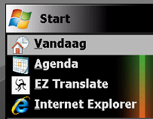

Launch the program and you will see the main screen:

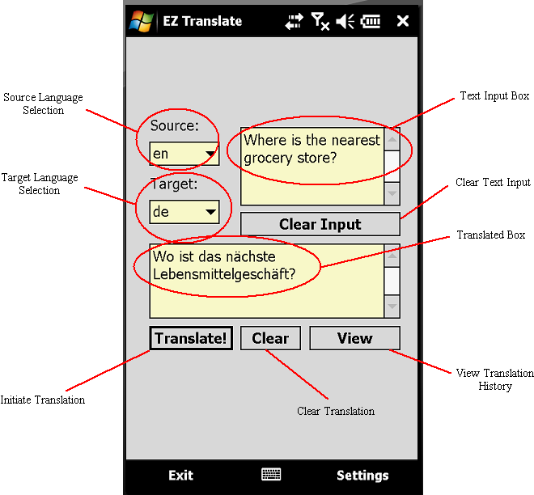

This screen is made to be as obvious as possible, nevertheless, the parts of the main screen are shown above.

To use the program, you would first type in the Text Input Box the phrase you wish to translate. After inputting the phrase, select the language this phrase is in by selecting it in the Source Language Selection list. This list uses international abbreviations such as ‘en’ for English, ‘de’ for German, ‘nl’ for Dutch, etcetera. Once you have input the selection of your source language, select the language you desire the translation to be in by selecting it in the Target Language Selection list. When you have finished, click the ‘Translate!; button and the application will perform the translation based on your selections. Also, the application will save your selections for you to access later, if desired. It will also give you the ability to export your activities in the form of a text file that can be read by any text viewer both on and off the phone.

Use the ‘Clear Input” button to clear the Text Input Box when you want to perform a fresh translation. You can continue to add to the text input box as much as you like which will also show longer results in the Translated Box. To clear this box, use the ‘Clear” button.

To view the history of translations since the time the application was installed on the phone, click the ‘View’ button on the main screen.

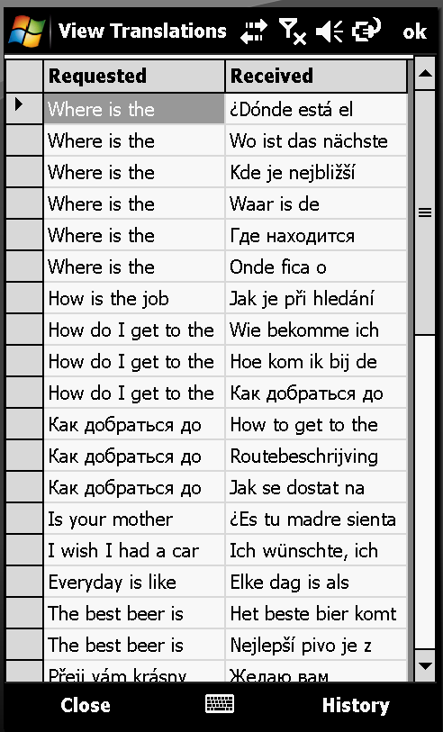 Stored Translations

This application has been designed with many different screen sizes in mind, therefore you are able to shift the size of the data display by clicking the line separating the columns ‘Requested’ and ‘Received’:

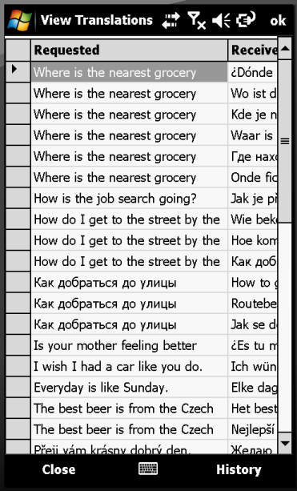 More Requested Translations

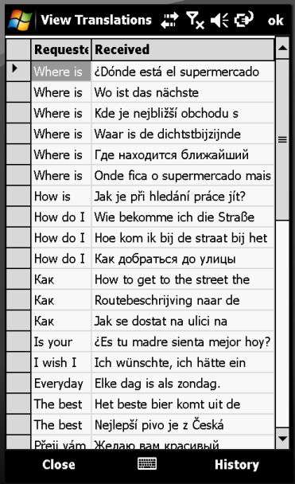 More Received Translations

Further, the application has the ability to switch to landscape view if your PocketPC supports it:

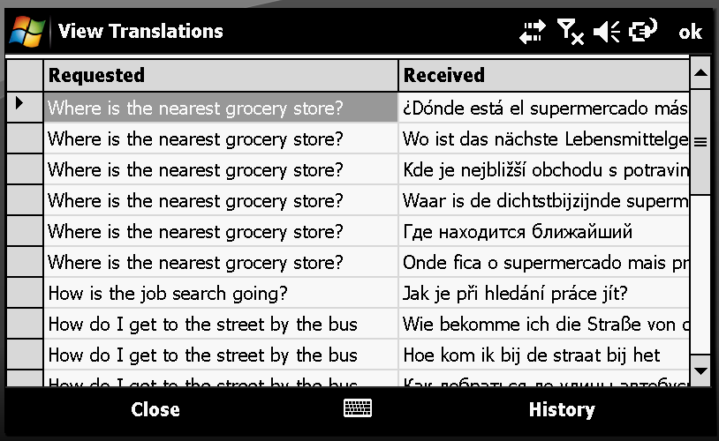 Landscape View Translations

You can export your translations by clicking the History → Export buttons:

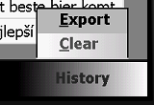

Which will return a successful dialog when the file is saved.

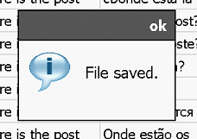

Lastly, you can delete your historical translations by selecting ‘Clear’ from the history menu. A dialog will ask you if you are sure you would like to delete the history:

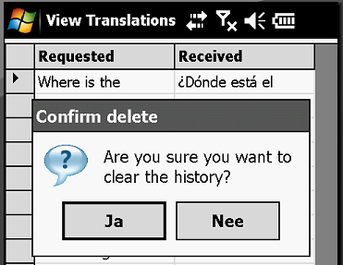

If you confirm the deletion, then the entire history will be erased since the application was installed on the phone.

Back on the main screen, there is a ‘Settings’ button,

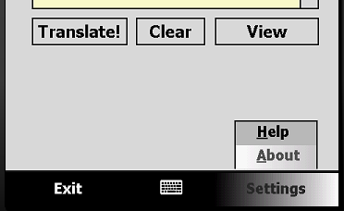

there you will see the ‘Help’ and ‘About’ dialogs. The help will provide a contact to our support department. In the ‘About’ dialog, you will see information about the application and the phone it is installed on:

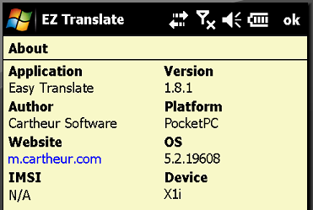 About Dialog

This screen will reveal the name and publisher of the application, its version and platform as well as access to a mobile website and the device name. If the security features of the phone are not high, you will see the IMSI number. This also depends on the manufacturer of the phone. Also on this screen, you can check if there is an update to the application.

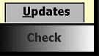

If there are any updates, you will be directed to download and install it. NOTE: Be certain to backup the database containing your translations. Through ActiveSync you can Explore the file system of your phone. Navigating to Program Files/eztranslate/db you will find the “EasySessions.db” file. Copy this to a suitable location on your phone or desktop computer. Once the upgrade has been performed, simply replace the new file with your old one. Your history of translations will be saved.

In the help section, you will find a link to the License Agreement:

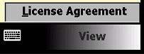

Please take a the time to read the license agreement as it stipulates the terms under which you can and cannot use the software. You are responsible for following this agreement. If you have any questions, please contact support.

Lastly, EZ Translate is designed to get out of your way when and if you don’t need it. Many times it is desirable to perform translations and utilize the generated text in other applications. You can do this by minimizing the application to the taskbar:

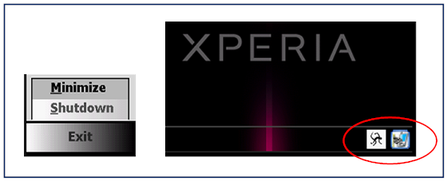 Minimize Windows 6.1

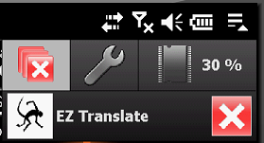 Minimize Windows 6.5.x

Clicking on the icon in the taskbar (Windows 6.1) or from the drop bar (Windows 6.5.x) will bring the application out from the background and show you the main screen.

Errors You May Experience

During your use of EZ Translate you may experience some input errors, these errors are no cause for alarm but try to communicate to you how to best correct information that is required by the program for its operation. The following screen shots reflect the errors you may experience.

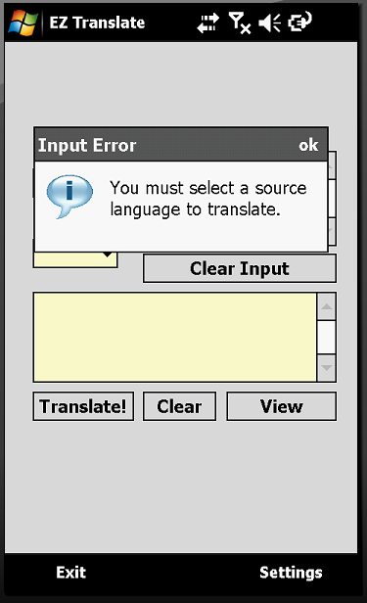 Error Source Language

To correct this error, be sure to select a source language from the list:

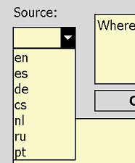Source Language List

Another error you may experience is:

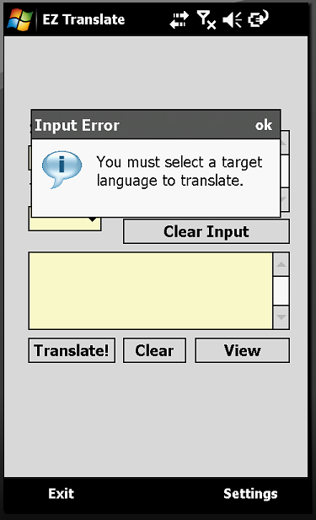 Error Target Language

To correct this error, be sure to select a target language from the list:

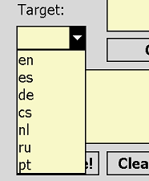 Target Language List

If you do not input at least some text into the text input box, you will receive the following error:

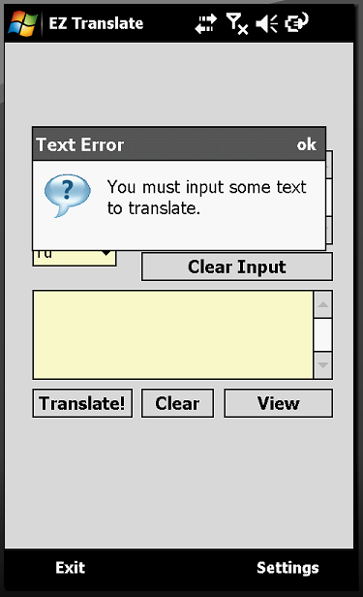 Error Input Text

Inputting some text will correct this error:

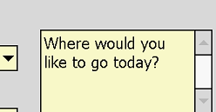 Text Input Box

Thank you for purchasing EZ Translate, we hope that you enjoy your experience with our product and find a great many uses for it. If you have any suggestions for improvement or have ideas you would like our development team to know of, please contact us at support@cartheur.com.

Appendix: Error Codes & Self Help

This section will allow you to diagnose error messages you may see during your use of the product. Please make yourself aware of these error codes and how they are most often remedied. If you have difficulty, please feel free to contact support at support@cartheur.com.

Error 20: Cannot establish a connection with the internet. Check to see if your GSM operator supports an
internet connection, alternatively find a WiFi signal which provides you access to the internet.

Error 32: Internet Explorer is not installed on the device. Check to see if your phone is configured
to use Internet Explorer, which comes standard with every Windows Mobile phone. If
Internet Explorer is not available because of the particular configuration of your phone,
copy the web address into a different browser, such as Opera.

Error 40: A problem with the data streaming from the server. This message will contain information if
there is corruption in the data stream. Please note the reported codes when having to contact support.

Error 51: Minimize failed to initialize. This error is often due to heavy security settings on the device
which does not allow the application to place its icon in the tray (Windows Mobile 5.0 and
6.1 only). Check the security settings by going to Start → Settings → System.

